**Day 04: Mastering Dynamic Frontend Components for an Immersive Marketplace Experience**

On Day 4, I focused on creating **dynamic and engaging frontend components** that seamlessly integrate with Sanity CMS and external APIs. These components are designed to offer a highly interactive, user-friendly, and visually appealing marketplace experience. Below is a breakdown of the **core dynamic components** that were built:

**🚀 Powerful Dynamic Frontend Components Developed:**

* **Product Listing Components**: A dynamic, responsive grid of products intelligently displayed based on user preferences, availability, and real-time data.
* **Product Details Components**: Detailed product views, featuring high-quality images, in-depth descriptions, pricing, ratings, and special offers to captivate the user.
* **Card Components**: Clean, modern product cards that highlight essential product details, enhancing the browsing experience.
* **Checkout Components**: A fluid, intuitive checkout process with user-friendly cart updates, payment gateway integration, and easy navigation for a smooth transaction experience.
* **Search Bar & Categories Components**: Advanced search functionality with dynamic filters, allowing users to effortlessly find and explore products by category, brand, price, and more.
* **Filter Pane Components**: Dynamic filter options that allow users to narrow their product search by specific attributes like price range, brand, or rating.
* **Related Products Components**: Smart product recommendations based on user behavior and preferences, enhancing product discovery and increasing engagement.
* **Header & Footer Components**: Sleek, minimalistic navigation and key information that guide the user journey effortlessly through the site.

**📸 Screenshots of Dynamic Components:**

* **Product Listing Components**: Showcase of dynamic product grid.

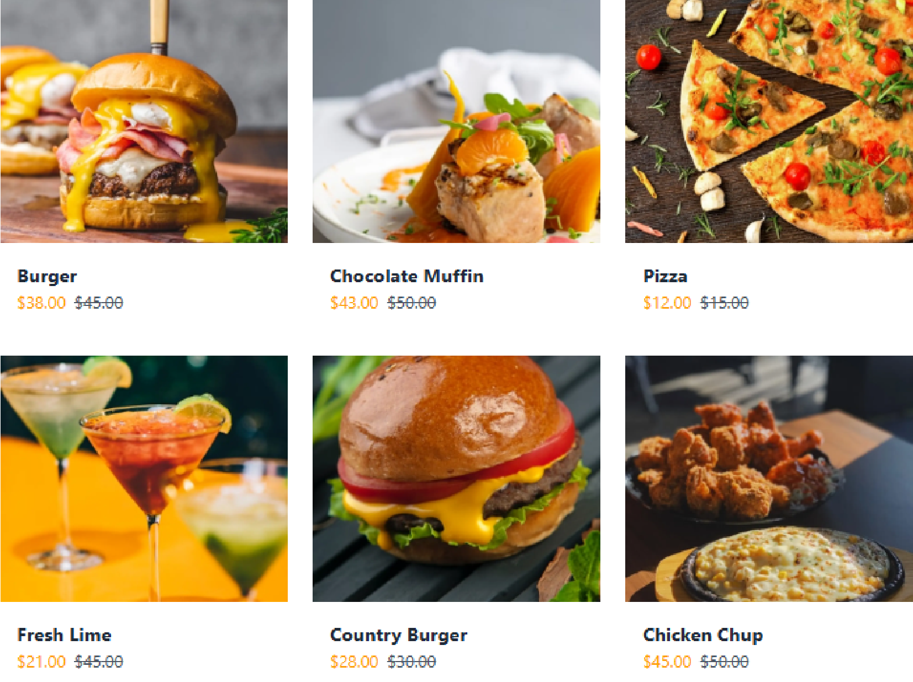

* **Product Details Components**: In-depth product views with immersive details.

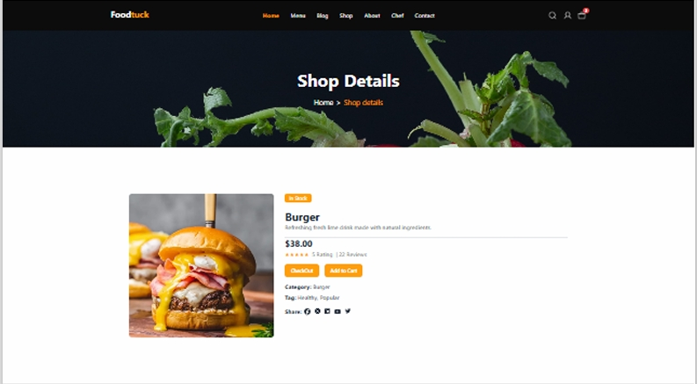

* **Card Components**: Clean and minimalistic design for easy browsing.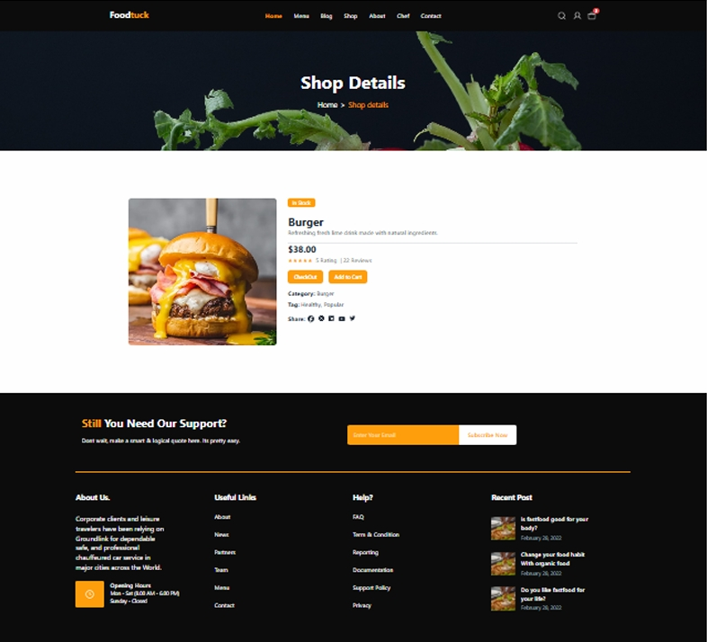
* **Checkout Components**: Seamless checkout process with a streamlined flow.

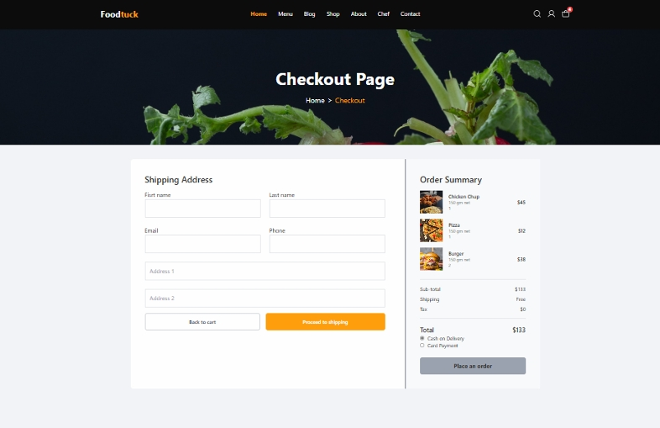

* **Search Bar & Categories Components**: Effortless searching and category filtering.

